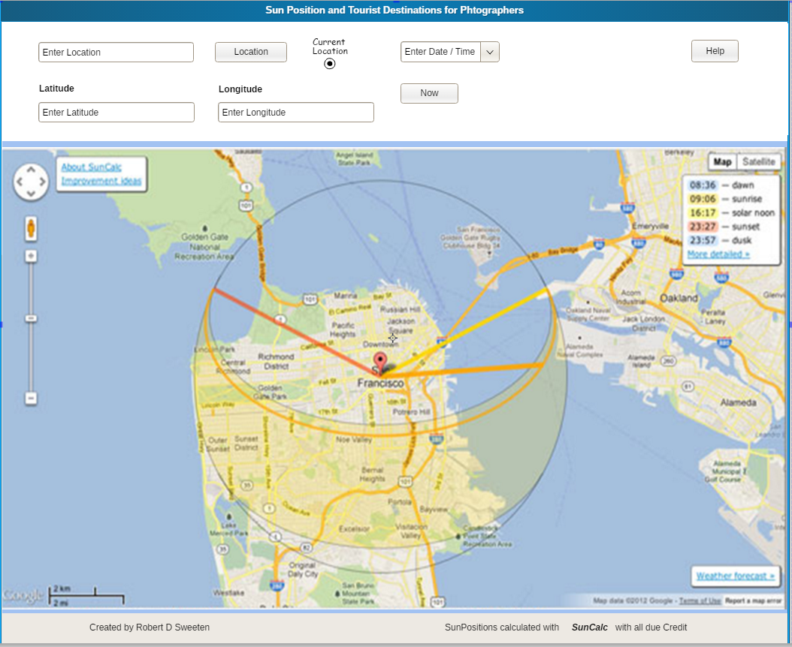

More Detail

A location is entered via either the Location field or by entering a Lattitude and Longitude and clicking on the Location button Clicking on the Current Location Checkbox will select the current Location.
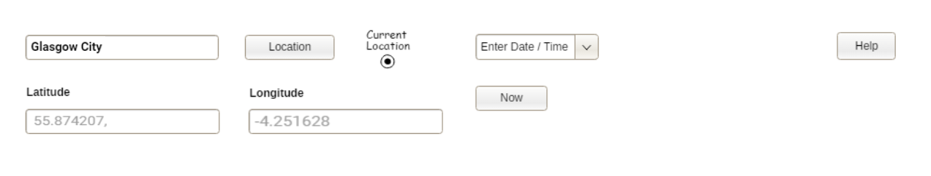

Then a Date and time (if required) is enterd using the Date and Time Picker. Clicking on the Menu icon at the end of the Date / Time Field will display the Date picker
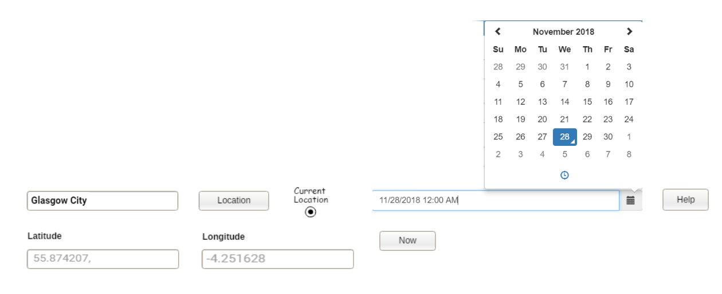
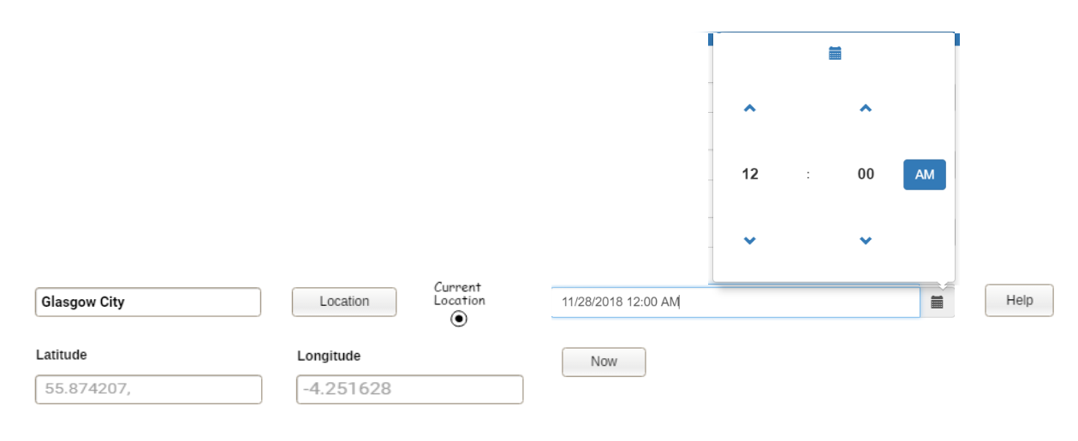
Clicking on the Clock face at the base of the Date Picker will select the Time Picker
A Time is selected using the arrows.

Once a Location has been selected using the Location Button Google Maps is called and a map for that Location is shown.

The Suncalc API is called and the Position of Sunrise and Sunset is displayed on the map as well as the current location of the sun:

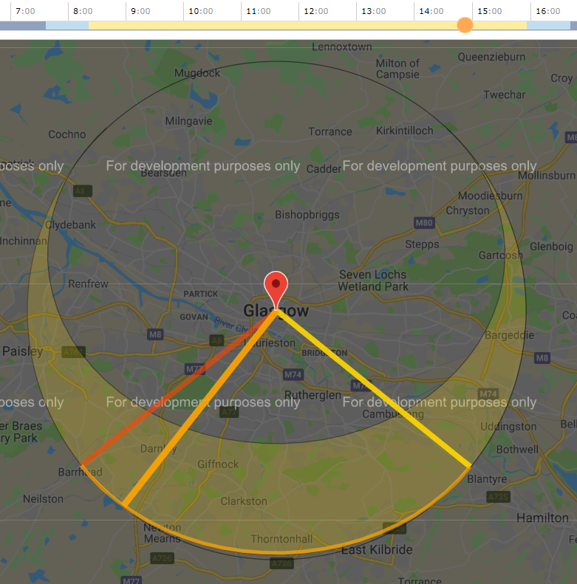

Sunrise
Sunset

Current Sun Position

A Google Maps API is called which access a Places Library and displays Tourist attractions:

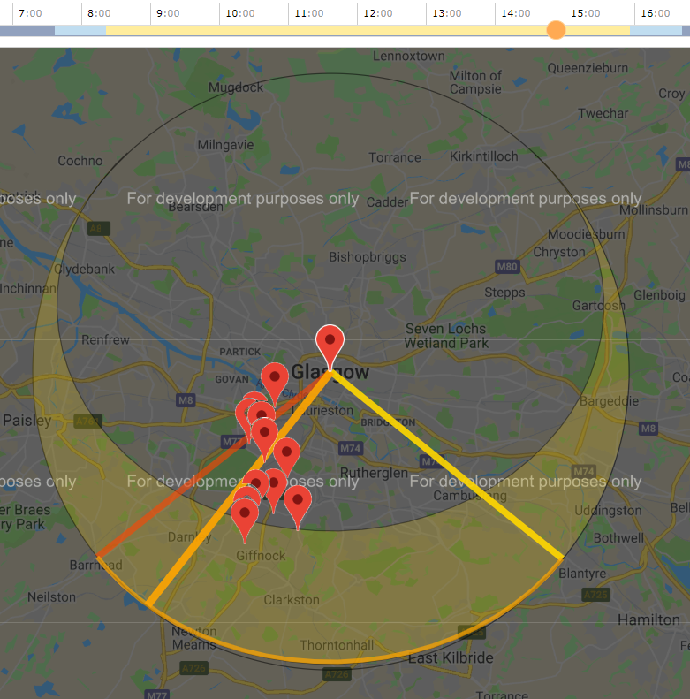

Tourist Attractions

